Recipe Display

Depending on the screen size the recipes either appear next to the recipe list, or as a full-screen view. The navigation options are the same in both cases besides the option to add a new recipe.

The following operations are possible when a recipe is displayed:



Press this button if you have prepared a recipe. The program maintains a history of your prepared recipes.



These buttons appear for recipes in PDF format. The allow it to enter additional notes. The recipe search includes the notes.



Provided that you have created some labels, this pushbutton is displayed. It is used to tag a recipe with labels. Pressing this pushbutton opens a dialog with all labels. You can assign labels by selecting the corresponding checkboxes:

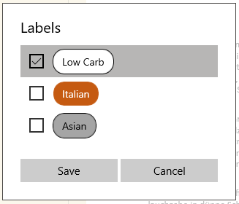

The chosen tags are displayed above the recipe:



By pressing the plus-button you can add further labels. By pressing the cross, you remove labels.



Recipes in RTF format can be changed directly using the built-in text editor via this button.



You can store photos of your dishes in the collection. This button takes you to the photo collection of the currently displayed recipe.



Switch to full-screen mode. (The button is displayed only, if you are not already in full-screen view.)

 / 

Add or remove a recipe from the favorites list.



The menu contains the following functions:

•       *Open* – Open the recipe in an external program, such as for example a PDF Viewer.

•       *Share* -Allows you to share a recipe, like for example by sending it as an email attachment.

•       *Change category* -allows you to move a recipe to a different category.

•       *Rename recipe*

•       *Delete recipe*

* *Change caloric information*
* *Scan recipes for caloric information* – Scans all recipes of the current category or all categories for caloric information (“xx kcal”).
* *Export database*
* *Import database* – These functions are used to export and import the database containing the cooking history and the caloric information. The functions are useful for backup purposes or if the app is used on several computers.